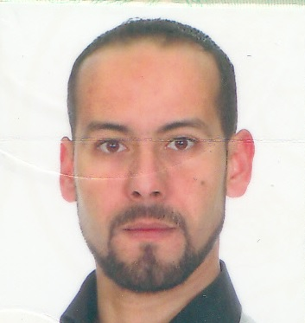**BOULKOUR Ali**

City Sakiet Sidi Youssef Building 2037 No. 1140  
25 000 Constantine, Algeria.  
E-mail: boulkour.ali@gmail.com  
Phone: +213 661 281 813

**PERSONAL DATA:**

Date of Birth: September 6, 1983  
Marital status: Maried  
Nationality: Algerian  
Military Service: completed

**QUALIFICATIONS:**

**- MENTOURI University of CONSTANTINE - Faculty of Engineering July 2008**  
State: Engineer in Mechanics  
Specialization: Building Mechanic  
Graduation Project: the balance of machines using rotary machine vibration measurement and balance MOVILOG 2  
Sort: first at the level of payment

**- MENTOURI University of CONSTANTINE - Faculty of Engineering July 2005**  
University graduates applied  
Specialization: Industrial maintenance  
Graduation Project: the study and completion of a mobile robot with wheels.  
Sort: first at the level of payment

**- Secondary ZIYADIYAH - CONSTANTINE June 2002**  
Bachelor of Mechanical Engineering

**EXPERIENCE:**

* Engineer operator welding machine PLASSER & THEURER APT 500C (COSIDER PUBLIC WORKS, DIVISION RAIL WORK) - M’sila – Algeria from september 2012 until today.
* Production engineer in the manufacturing company of hydraulic cylinders (SOVER) - Constantine – Algeria June 2011.
* National Company for Public Works equipment (bulldozers and composite jacks) - Constantine - Algeria January 2008.  
  * A course of education in the principles of hydraulics;  
  * A course of education in the management of production;

**SKILLS:**

Language: - Arabic: Mother tongue  
                        - French: Good  
                        - English: Average  
  
Computer: - Good proficiency software for Microsoft Windows & Office.

                       - Proficiency in the use of the program and three-dimensional mechanical

SOLIDWORKS 2010-2012. And AUTOCAD 2007

* Good knowledge of Photoshop CS4
* Installation and repair and maintenance of computer systems

**HONORARY CERTIFICATES:**

- Certificate of honor from the University MENTOURI of Constantine recognition of the good results during the period of study 2002 / 2005;   
- Certificate of honor from the University MENTOURI of Constantine recognition of the good results during the period of study 2005 / 2008;

* Certificate from PLASSER & THEURER Rail Way machines Type APT 500C (Welding machine), from 26/08/2013 to 30/08/2013 in Linz, Austria.